

**DOCUMENTATION: Working with JSON, Loops, and DOM Manipulation in JavaScript**

**Athor: Ismail Munyentwari**

**🧱 1. What Is JSON?**

**✅ Definition:**

**JSON (JavaScript Object Notation)** is a lightweight format for storing and transferring data between systems — such as between your **backend (server)** and **frontend (browser)**.

It is written as **text** but structured like **JavaScript objects**.

**✅ Example JSON File: movies.json**

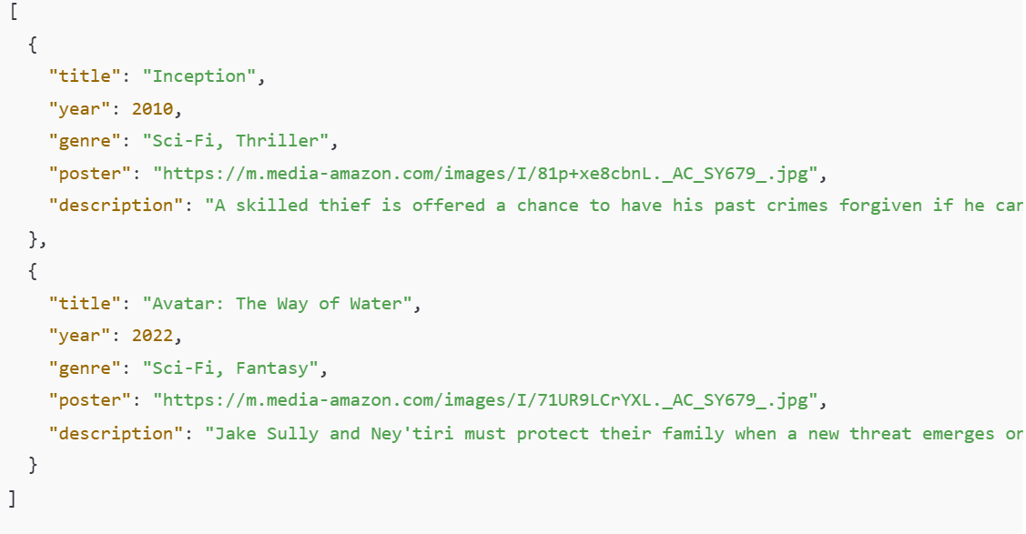

🟢 This file contains an **array of objects**, each representing one movie.

**⚙️ 2. Why JSON Matters in Real-World Apps**

* APIs (like YouTube, Netflix, Spotify, etc.) send data in JSON format.
* JSON helps **separate data from design**.
* It’s easy to **parse**, **read**, and **loop** through using JavaScript.

**🧠 3. How to Load (Fetch) JSON Data**

You can load JSON data from a file or an API using the fetch() function.

**Example HTML structure (index.html):**

👉 **:::::::::::::::::::Create Html file and Add Mive Card Container ::::::::::::::::::::::::::::::::::::**

**📜 4. Step-by-Step: Fetching and Looping Through JSON Data**

**Your JavaScript file (app.js):**

// Step 1: Select the HTML element where we will render our data

const container = document.getElementById("movieContainer");

// Step 2: Fetch JSON data from an external file

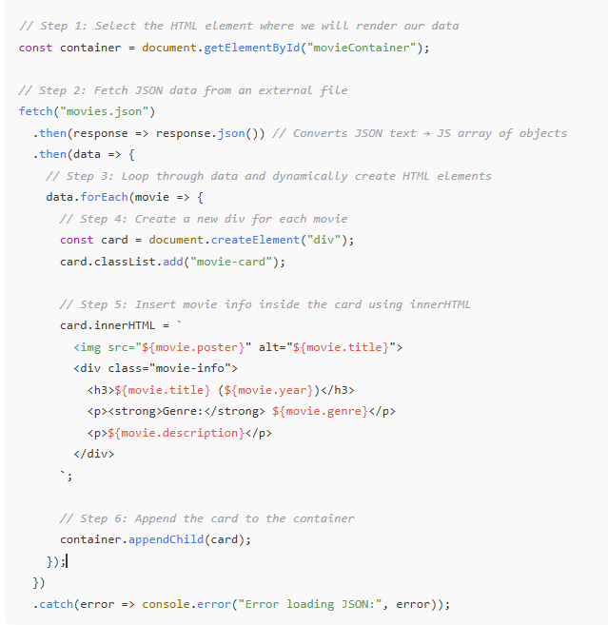

**Second way ::**

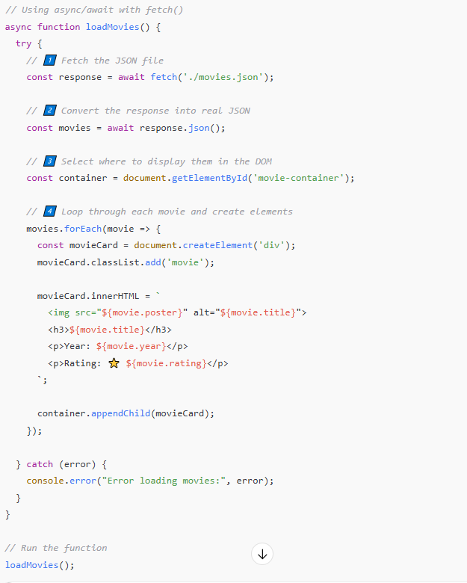

| **Step** | **Description** |
| --- | --- |
| fetch('./movies.json') | Loads the file from the same folder |
| await response.json() | Converts the raw text response to actual JSON data |
| forEach(movie => {...}) | Loops through each movie object in the JSON array |
| document.createElement() | Creates new HTML elements dynamically |
| innerHTML | Inserts the movie’s data inside those elements |
| appendChild() | Adds each movie card into the main container in the HTML |

**🧩 5. Explanation — What’s Happening Behind the Scenes**

| **Step** | **What It Does** | **Example** |
| --- | --- | --- |
| 1 | Select HTML container | document.getElementById("movieContainer") |
| 2 | Fetch data from JSON file | fetch("movies.json") |
| 3 | Convert to JS objects | .then(response => response.json()) |
| 4 | Loop through the array | data.forEach(movie => {...}) |
| 5 | Create HTML elements dynamically | document.createElement("div") |
| 6 | Add the data into HTML | innerHTML = ... |
| 7 | Display in the DOM | container.appendChild(card) |

**🧮 6. DOM Manipulation in Action**

**DOM (Document Object Model)** is the structure of your web page that JavaScript can modify in real-time.

We used DOM manipulation to:

* **Create new elements:** document.createElement()
* **Add classes:** element.classList.add()
* **Insert data:** element.innerHTML = ...
* **Attach to the page:** parent.appendChild()

This allows you to build full pages dynamically using JSON data.